**PROJECT Bank record generations**

**Objective** To write a program that parses and processes bank data from a file.

***PROJECT DESCRIPTION***

Bank of IIT has gotten their hands on some interesting data which will allow for possible loans to various clients from various regions.

Accompanying the labs specs is a csv (comma separated value) file named

**bank-Detail.csv** which contains valuable raw data to allow the bank to process loans based on client details from the file.

You need to parse the data and print record data for future loan considerations.

**When BankRecordTest is initiated:**

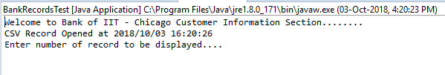

**To Display n Records after getting Input from the User: [Optional]**

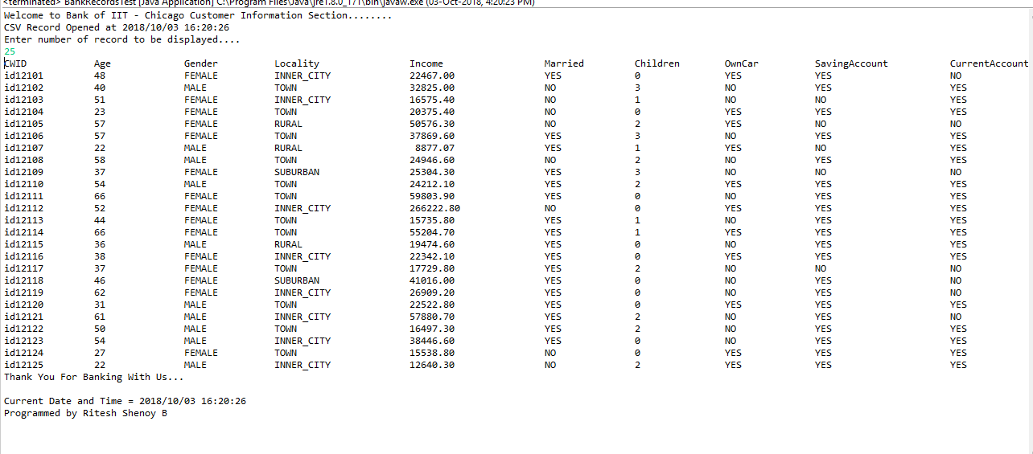

**To Display total records inside the .csv file**

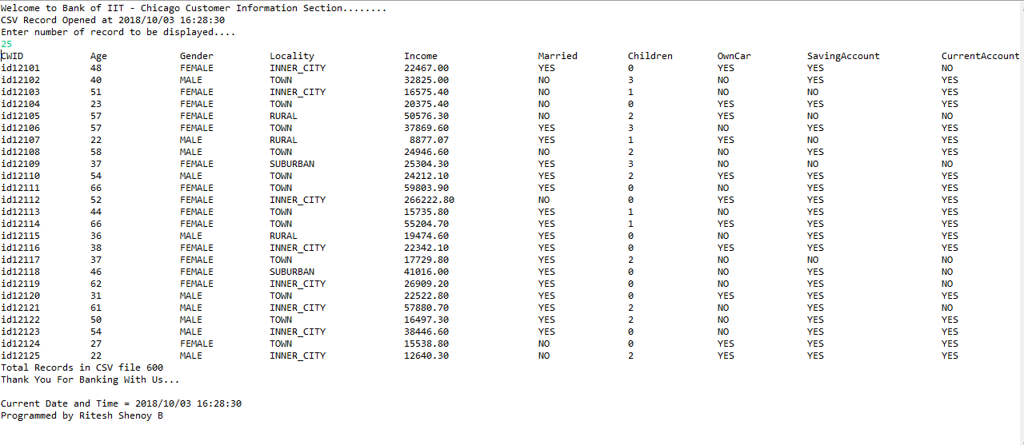

**Exception if File is not available:**

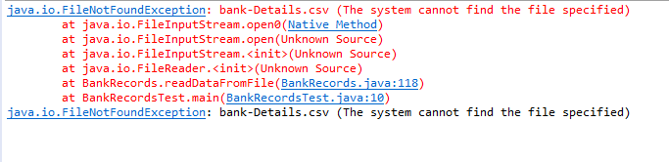

**If user enter more than existing data in file**

